

**Smt. Chandaben Mohanbhai Patel Institute of Computer Applications**

**CASE STUDY**

**On**

**CMPICA Website**

**University Elective UG – III**

**CA224 – Introduction to Web Designing**

**Submission Date: 18th November, 2017**

**Submitted By** : **Submitted To**:

1. 16ce068 Patel Jainil A. Dr. Nirali Honest

1. HomePage of website:

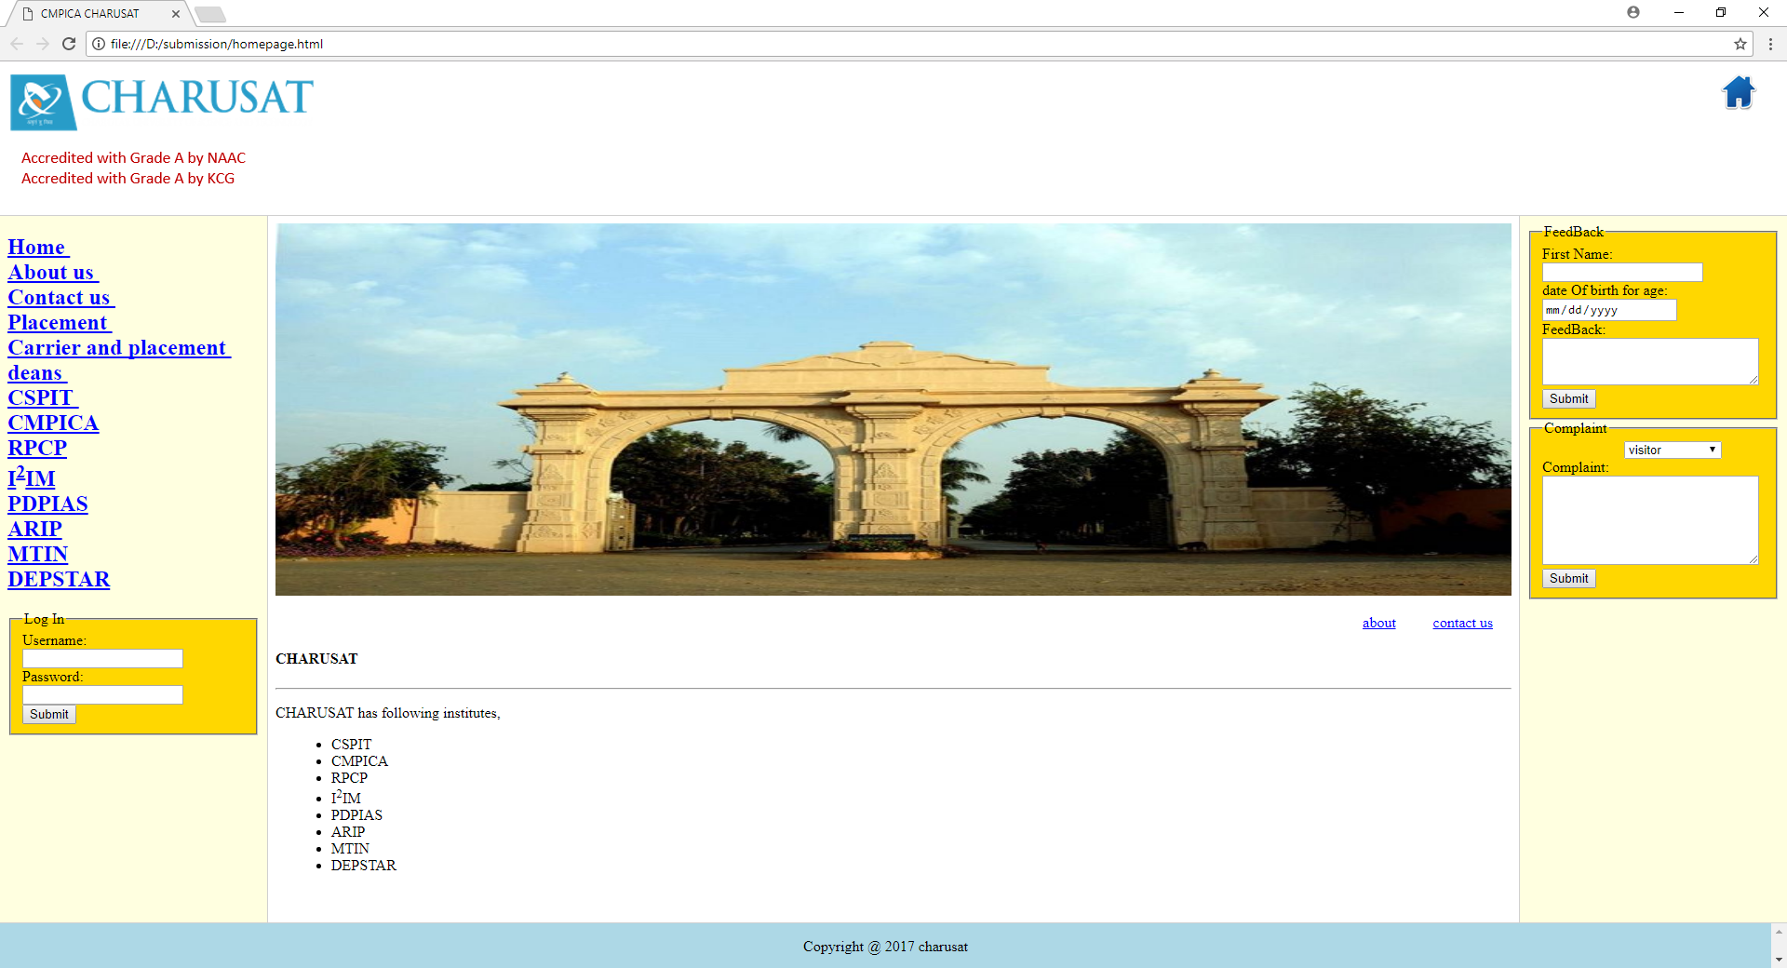

1. About us:

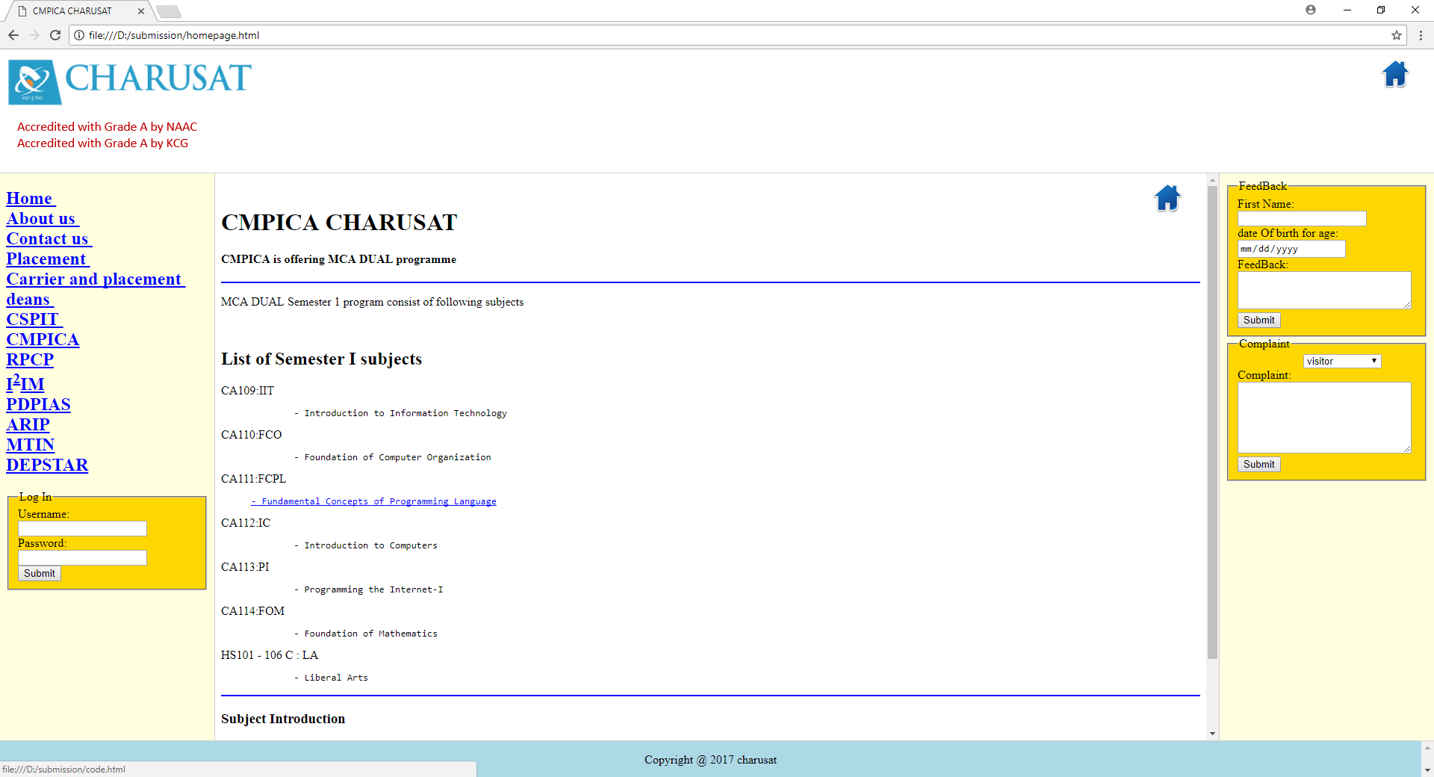

1. Language mostly used in charusat.

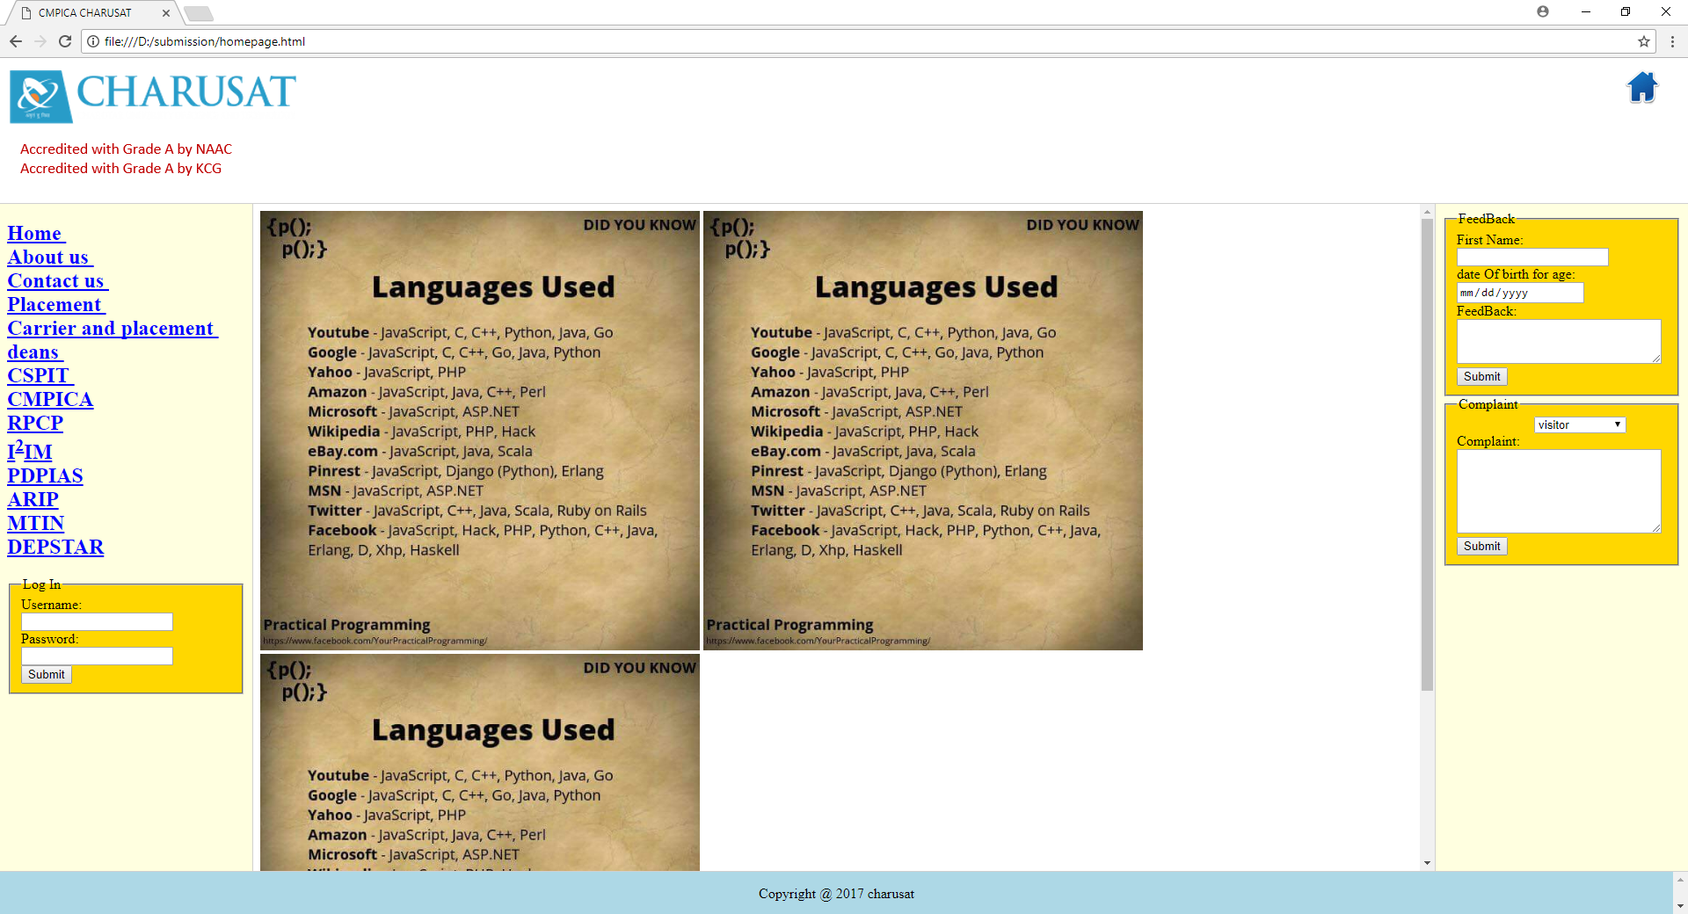

1. Quiz

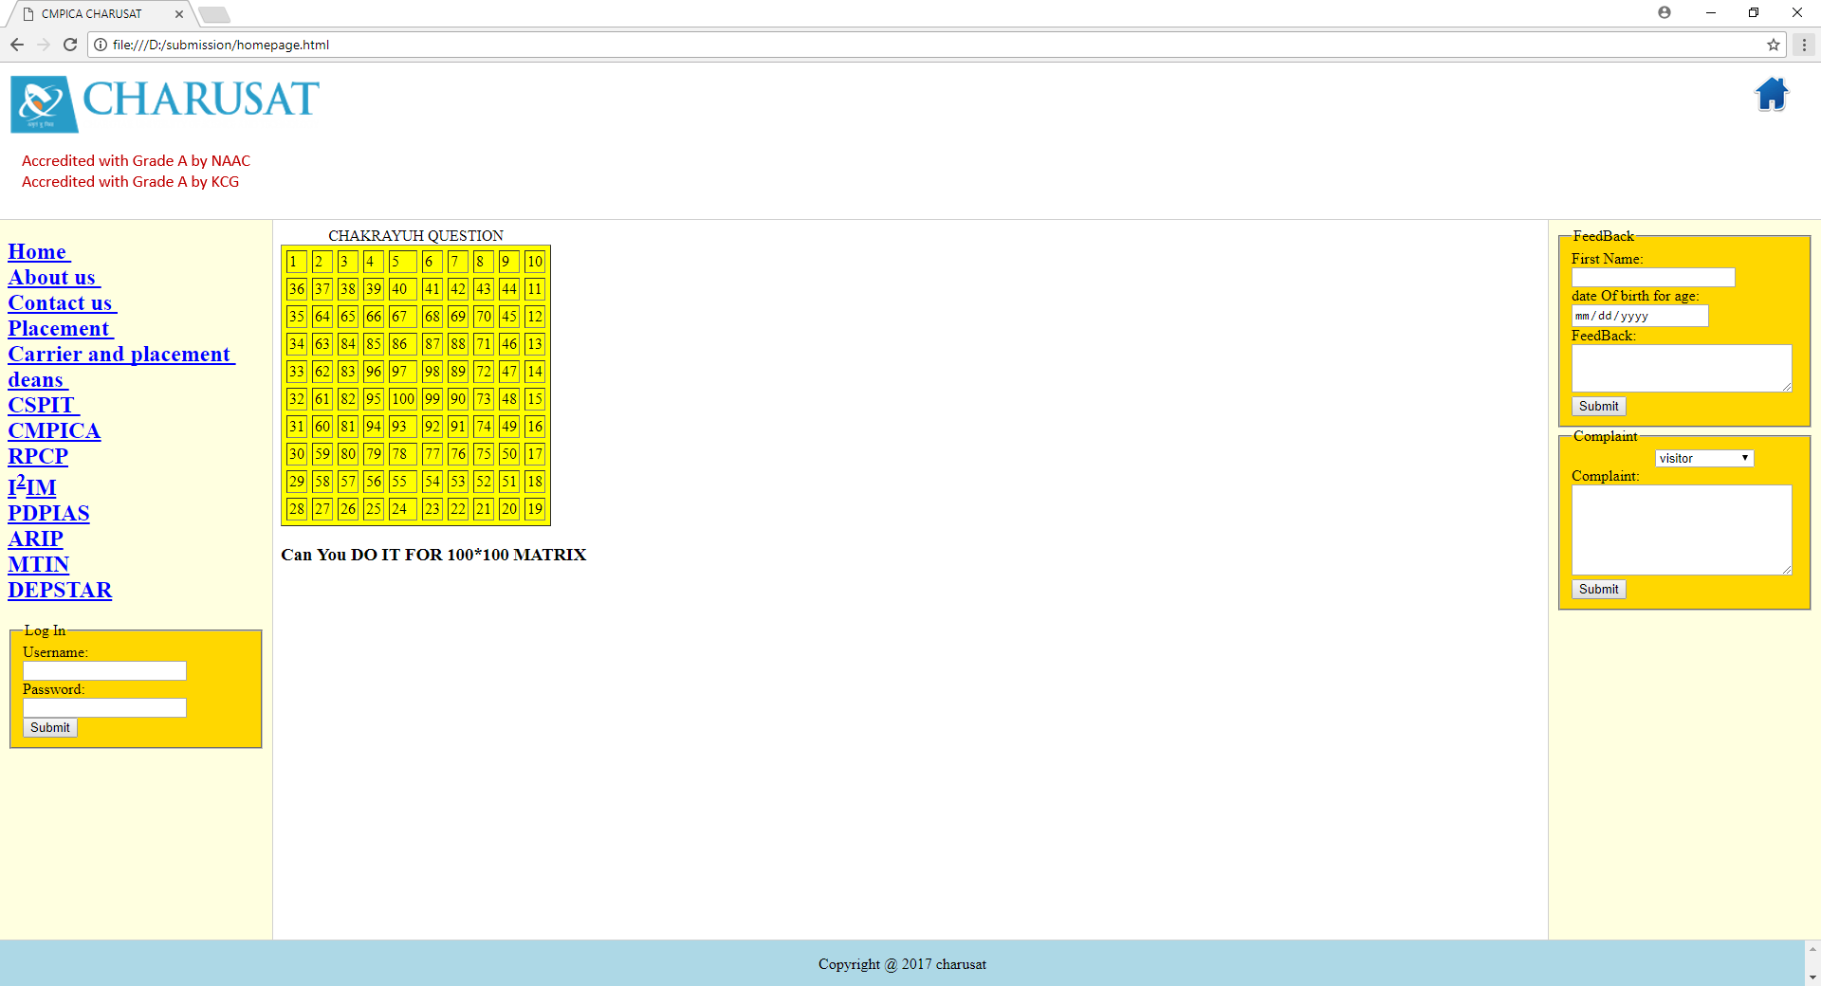

1. Contact us.

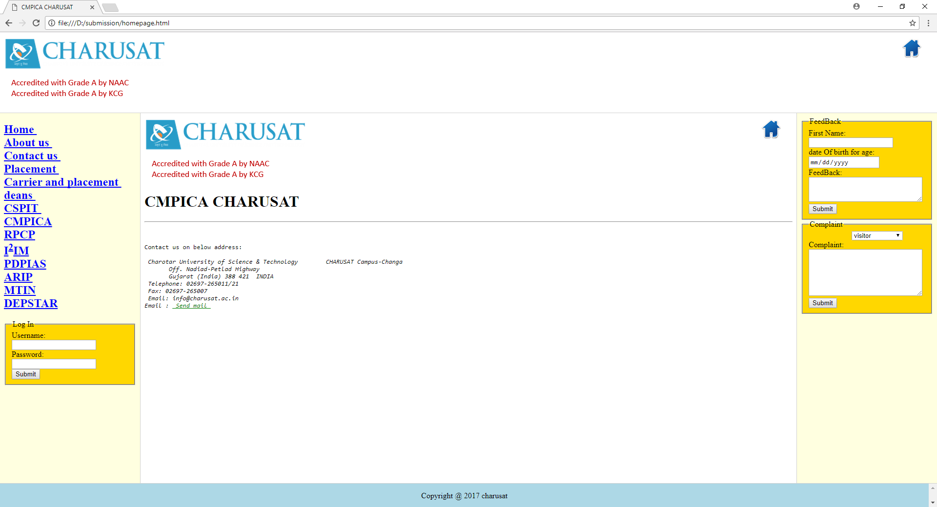

1. Placement.

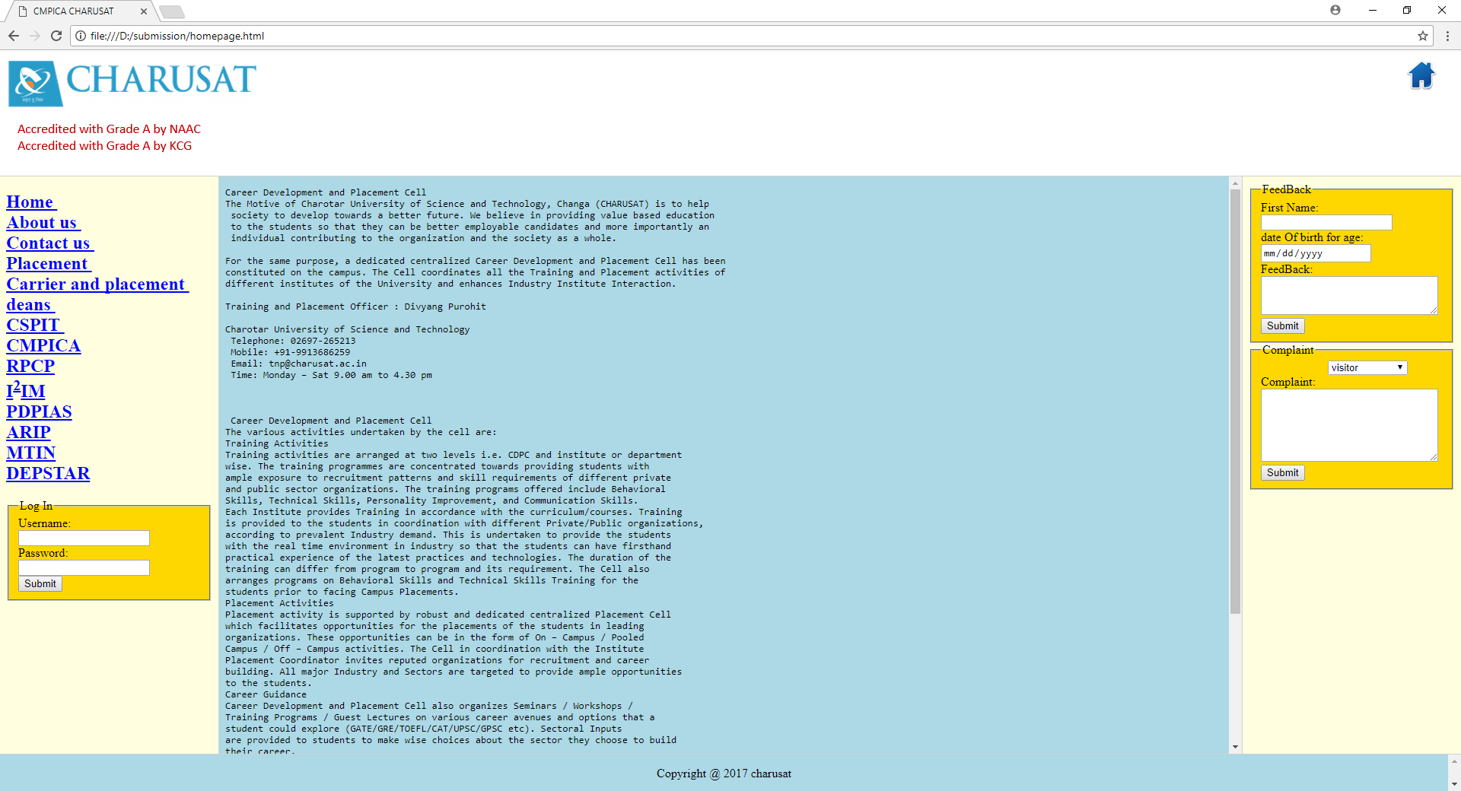

7. Carrier and placement.

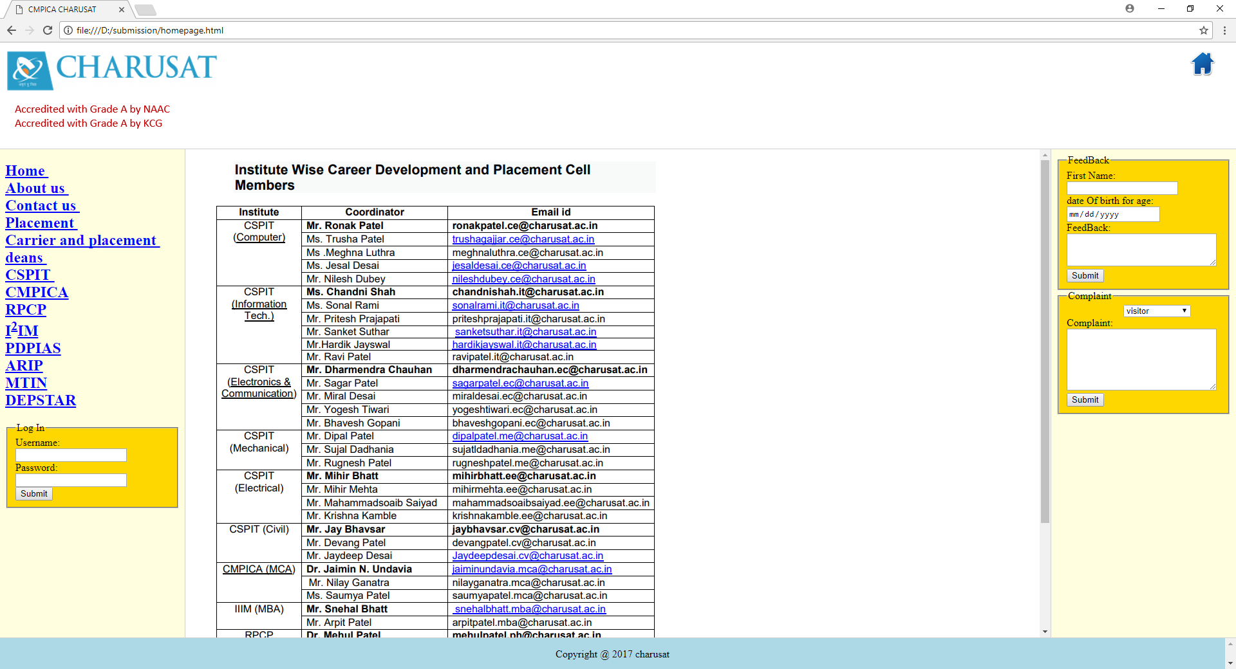

8. Deans of university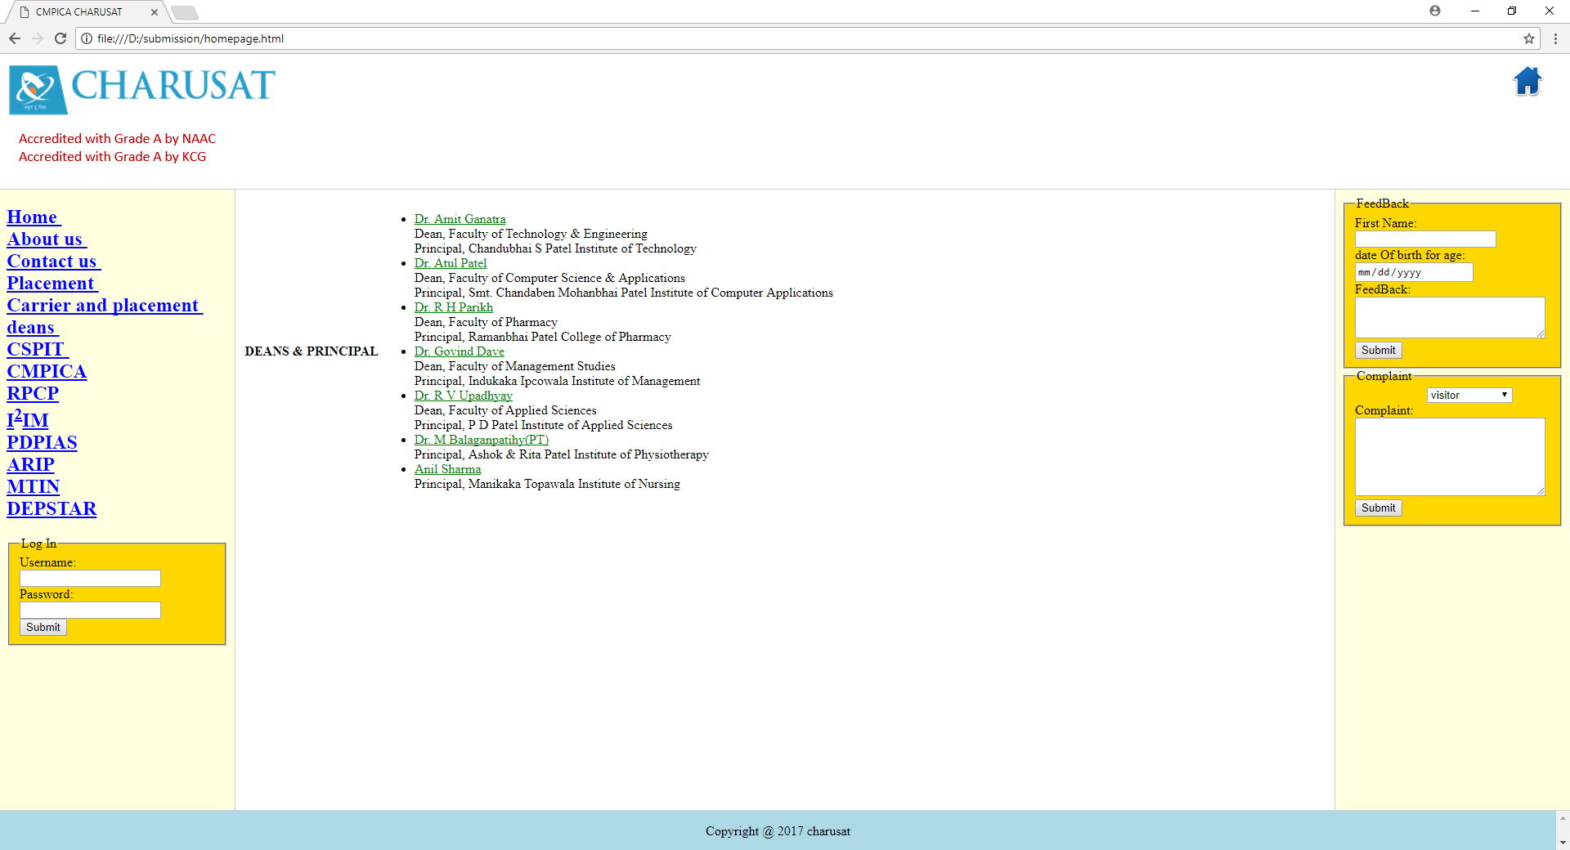

1. Cspit

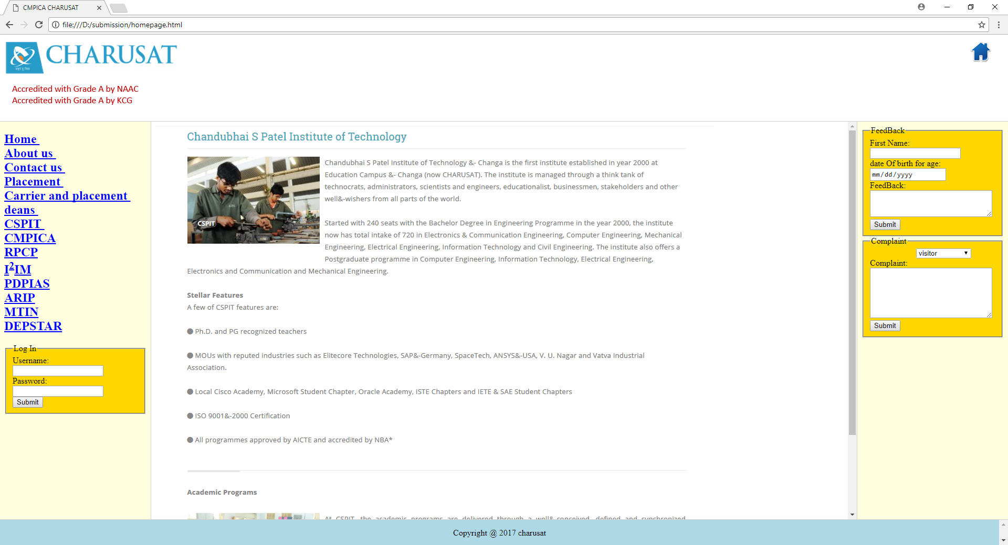

10. Cmpica 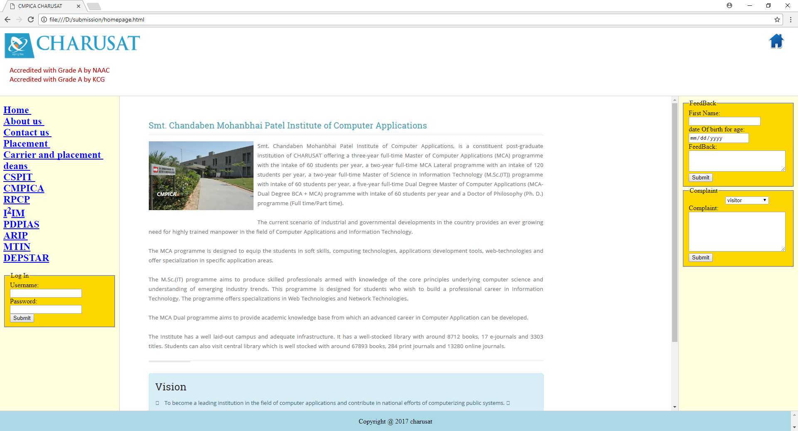

11. Rpcp

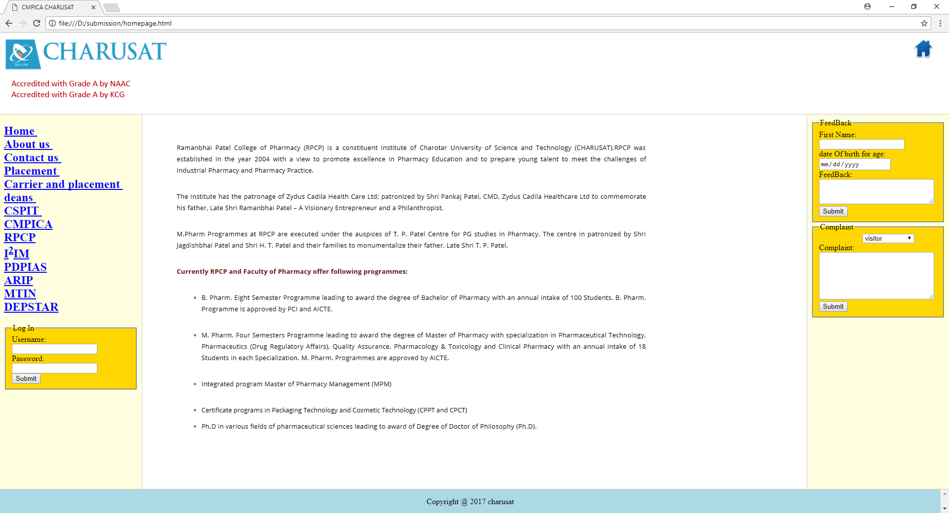

12. I^2 IM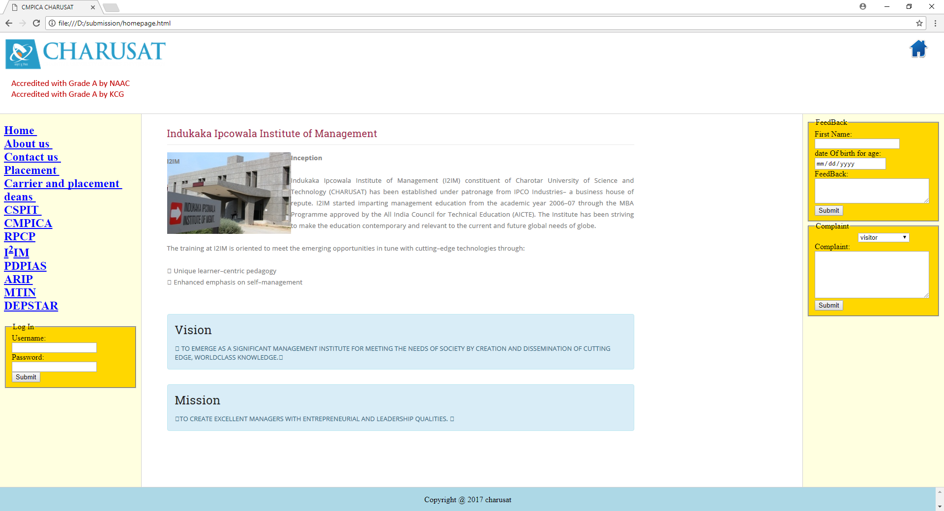

13. pdpias 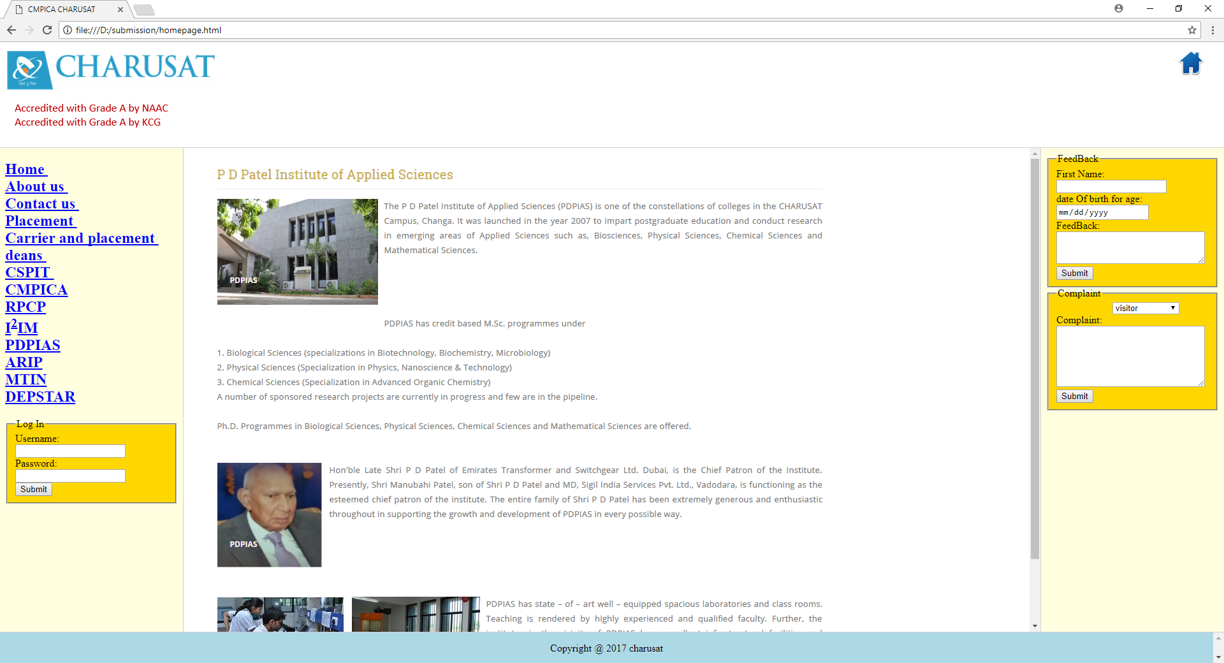

14.Arip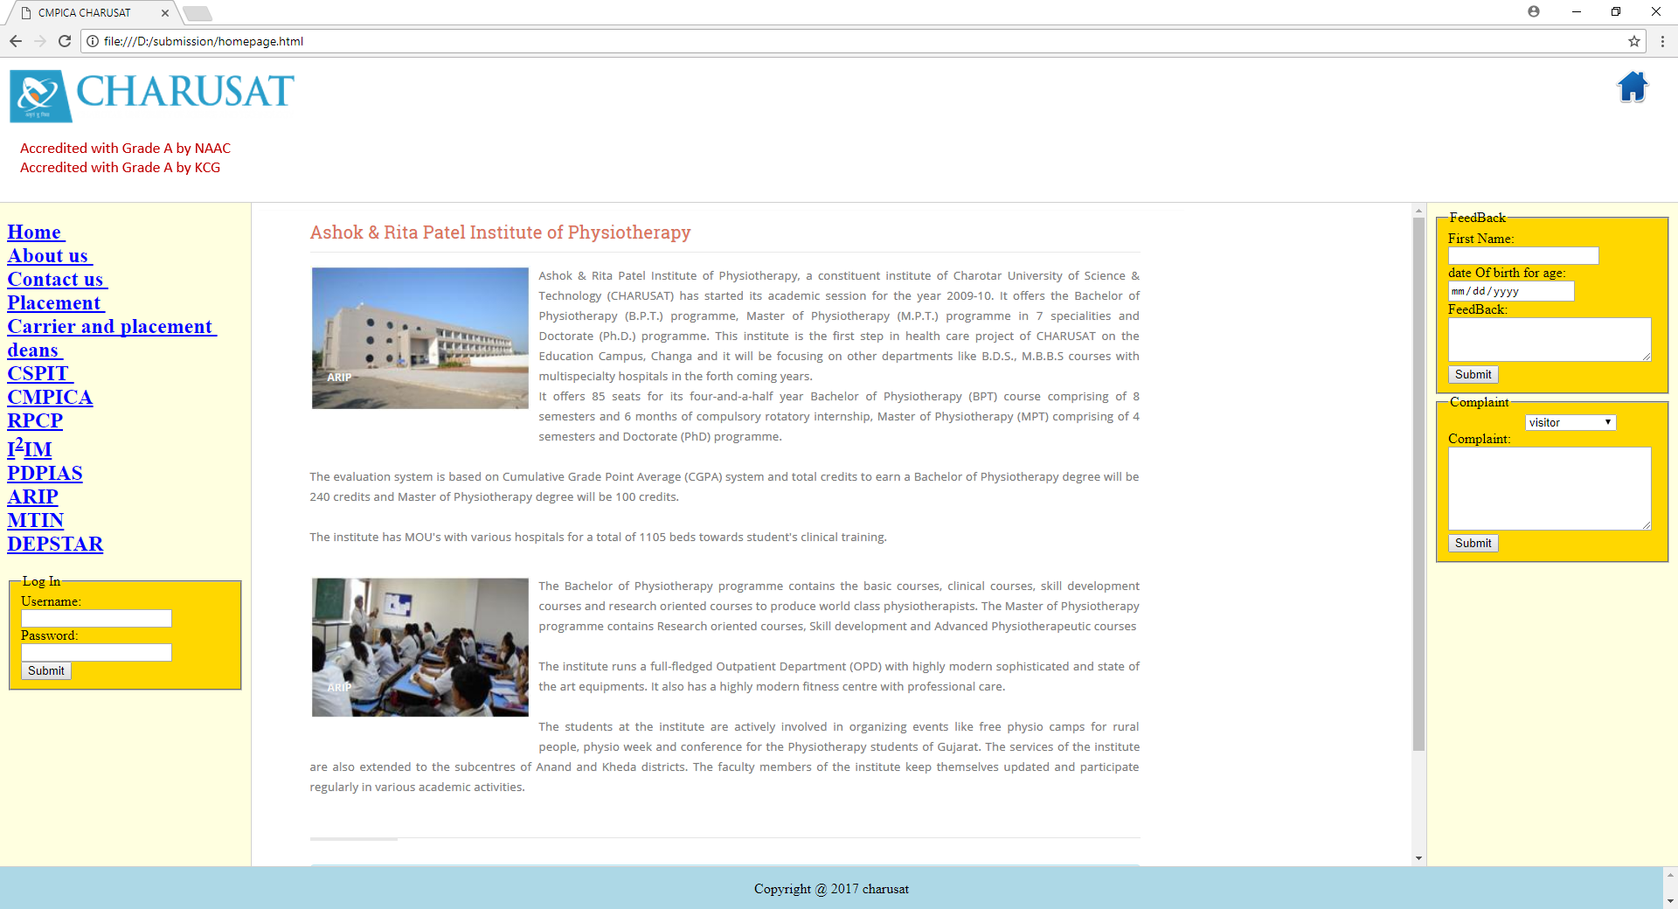

\

15. Mtin

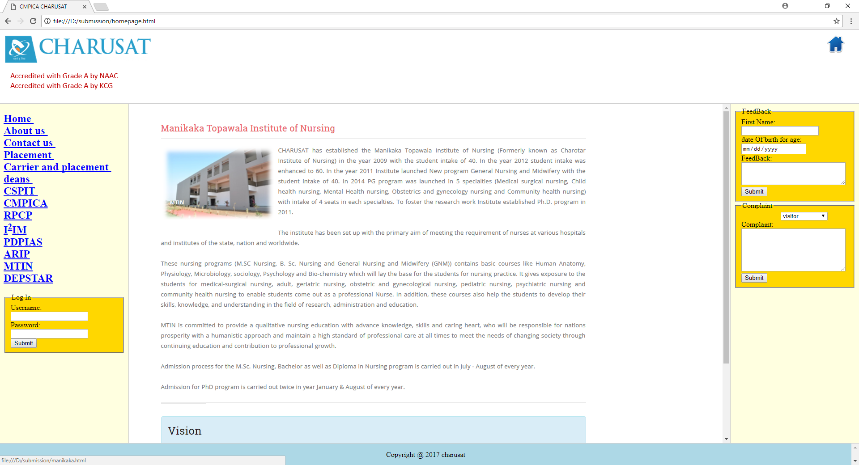

16. Depstar

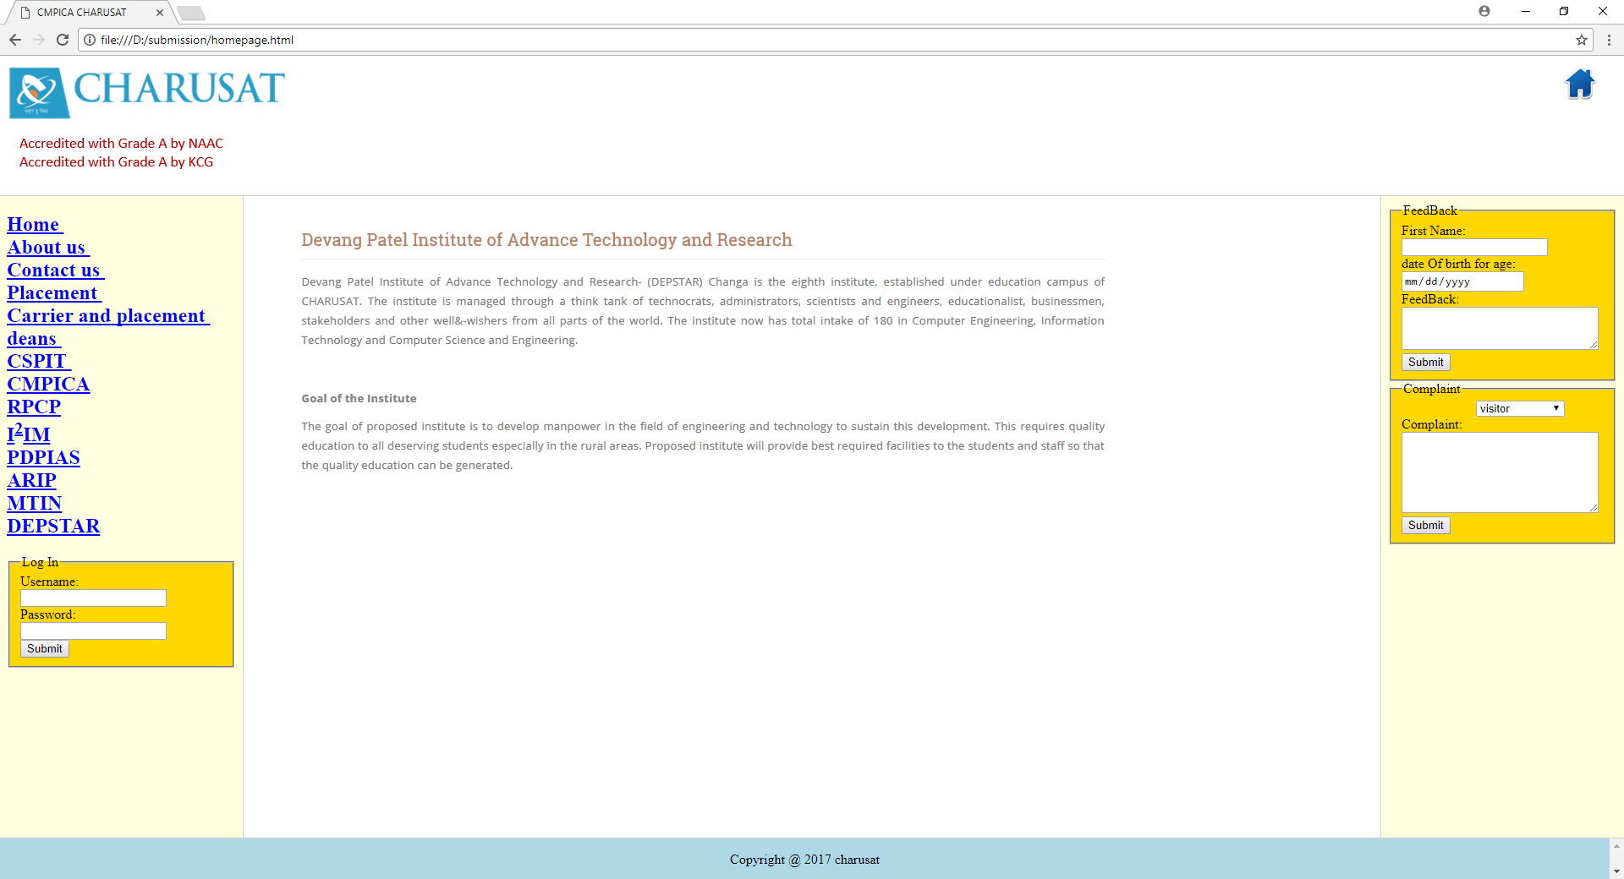

17. login page, feedback, complaint

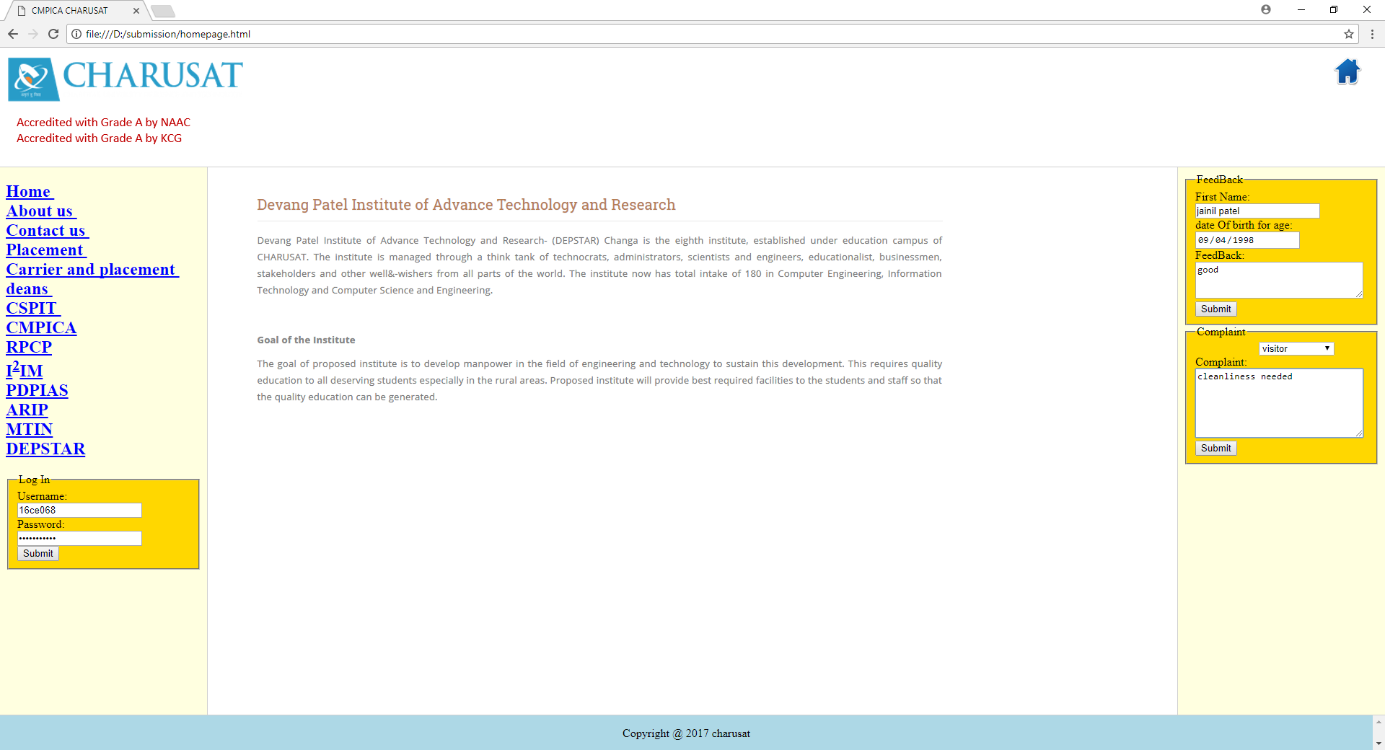

Source Code

**1.about.html**

<!DOCTYPE html>

<html>

<head>

<title>CMPICA CHARUSAT</title>

</head>

<body alink="red" link="green" vlink="blue">

<a href="c1.html" style="float:right;margin:0 20px"><img src="home3.png" /></a>

<br>

<h1>CMPICA CHARUSAT</h1>

<h4>CMPICA is offering MCA DUAL programme</h4>

<hr color="blue">

<p>MCA DUAL Semester 1 program consist of following subjects</p>

<br>

<h2>List of Semester I subjects</h2>

<dl>

<dt>

CA109:IIT

</dt>

<dd><pre> - Introduction to Information Technology</pre>

</dd>

<dt>CA110:FCO

</dt>

<dd><pre> - Foundation of Computer Organization</pre>

</dd>

<dt>

CA111:FCPL

</dt>

<dd><pre><a href="code.html">- Fundamental Concepts of Programming Language</a></pre>

</dd>

<dt>CA112:IC

</dt>

<dd><pre> - Introduction to Computers</pre>

</dd>

<dt>CA113:PI

</dt>

<dd><pre> - Programming the Internet-I</pre>

</dd>

<dt>

CA114:FOM

</dt>

<dd><pre> - Foundation of Mathematics</pre>

</dd>

<dt>

HS101 - 106 C : LA

</dt>

<dd><pre> - Liberal Arts</pre>

</dd>

</dl>

<hr color="blue">

<h3>Subject Introduction</h3>

<dl>

<dt>

CA109:Introduction to Information Technology

</dt>

<dd><pre>

This subject covers the fundamental concepts of information technology.</pre>

</dd>

</dl>

<p><a href="about.html">List of Semester 1 subjects</p>

</html>

**2.ashok.html**

<!DOCTYPE html>

<html>

<head>

<title>Cspit</title>

</head>

<body alink="red" link="green" vlink="blue">

<img src="ashok.png" />

</body>

</html>

**3.c1.html**

<!DOCTYPE html>

<html>

<head>

<title>CMPICA CHARUSAT</title>

</head>

<body alink="red" link="green" vlink="blue">

<img src="1.jpg" width="100%" height="400"/>

<br>

<ul style="list-style-type:none">

<li style="float:right;margin:0 20px;"><a href="contact.html" >contact us</a></li>

<li style="float:right;margin:0 20px;"><a href="about.html">about</a></li>

</ul>

<br>

<h4>CHARUSAT</h4>

<hr>

<p> CHARUSAT has following institutes,

<ul style="float:left;margin:0 20px;">

<li>CSPIT</li>

<li>CMPICA</li>

<li>RPCP</li>

<li>I<sup>2</sup>IM</li>

<li>PDPIAS</li>

<li>ARIP</li>

<li>MTIN</li>

<li>DEPSTAR</li>

</ul>

</body>

</head>

**4.carrier.html**

<!DOCTYPE html>

<html>

<head>

<title>CONTACT US</title>

</head>

<body alink="red" link="green" vlink="blue">

<img src="carrier.png" />

</body>

</html>

**5. chandabenmohanbhaipatel.html**

<!DOCTYPE html>

<html>

<head>

<title>Cspit</title>

</head>

<body alink="red" link="green" vlink="blue">

<img src="chandabenmohanbhaipatel.png" />

</body>

</html>

**6. contact.html**

<!DOCTYPE html>

<html>

<head>

<title>CONTACT US</title>

</head>

<body alink="red" link="green" vlink="blue">

<img src="charusat.png" />

<a href="c1.html" style="float:right;margin:0 20px" target="home" ><img src="home3.png" /></a>

<h1> CMPICA CHARUSAT </h1>

<hr>

<pre>

Contact us on below address:

<address>

Charotar University of Science & Technology CHARUSAT Campus-Changa

Off. Nadiad-Petlad Highway

Gujarat (India) 388 421 INDIA

Telephone: 02697-265011/21

Fax: 02697-265007

Email: info@charusat.ac.in

Email : <a href="mailto:info@charusat.ac.in"> Send mail </a>

</address>

</pre>

</body>

</html>

**7.cspit.html**

<!DOCTYPE html>

<html>

<head>

<title>Cspit</title>

</head>

<body alink="red" link="green" vlink="blue">

<img src="cspit.png" />

</body>

</html>

**8. dean.html**

<!DOCTYPE html>

<html>

<head>

<title>CONTACT US</title>

</head>

<body alink="red" link="green" vlink="blue">

<table ><tr >

<th >DEANS & PRINCIPAL</th>

<td >

<ul >

<li c><span><i></i> </span><div ><div >

Dr. Amit Ganatra<br>

Dean, Faculty of Technology & Engineering<br>

Principal, Chandubhai S Patel Institute of Technology

</div> </div></li>

<li c><span><i></i> </span><div ><div >

Dr. Atul Patel<br>

Dean, Faculty of Computer Science & Applications<br>

Principal, Smt. Chandaben Mohanbhai Patel Institute of Computer Applications

</div> </div></li>

<li c><span><i></i> </span><div ><div > Dr. R H Parikh<br>

Dean, Faculty of Pharmacy<br>

Principal, Ramanbhai Patel College of Pharmacy

</div> </div></li>

<li c><span><i></i> </span><div ><div >Dr. Govind Dave<br>

Dean, Faculty of Management Studies<br>

Principal, Indukaka Ipcowala Institute of Management

</div> </div></li>

<li c><span><i></i> </span><div ><div >Dr. R V Upadhyay=<br>

Dean, Faculty of Applied Sciences<br>

Principal, P D Patel Institute of Applied Sciences

</div> </div></li>

<li c><span><i></i> </span><div ><div >Dr. M Balaganpatihy(PT)=<br>

Principal, Ashok & Rita Patel Institute of Physiotherapy

</div> </div></li>

<li c><span><i></i> </span><div ><div >Anil Sharma<br>

Principal, Manikaka Topawala Institute of Nursing

</div> </div></li>

</ul>

</td>

</body>

</html>

**9.devang.html**

<!DOCTYPE html>

<html>

<head>

<title>Cspit</title>

</head>

<body alink="red" link="green" vlink="blue">

<img src="devang.png" />

</body>

</html>

**10. feedback.html**

<!DOCTYPE html>

<html>

<head>

<title>Feedback</title>

</head>

<body alink="red" link="green" vlink="blue" bgcolor="lightyellow">

<form >

<fieldset style="background-color:gold">

<legend>FeedBack</legend>

<label for="first-name">First Name:</label>

<input type="text" name="first-name" id="first-name"><br/>

<label for="age">date Of birth for age:</label>

<input type="date" name="year" id="ages"><br/>

<label for="feedback">FeedBack:</label>

<textarea rows="3" cols="30" name="feedback" id="feedback"></textarea>

<input type="submit" value="Submit">

</fieldset>

</form>

<form >

<fieldset style="background-color:gold">

<legend>Complaint</legend>

<label for="feedback"> &nbsp &nbsp &nbsp &nbsp &nbsp &nbsp &nbsp &nbsp &nbsp &nbsp &nbsp </label>

<select>

<option value="visitor">visitor</option>

<option value="student">student</option>

<option value="new Students">new Students</option>

</select><br/>

<label for="feedback">Complaint:</label>

<textarea rows="6" cols="30" name="feedback" id="complain"></textarea>

<input type="submit" value="Submit">

</fieldset>

</form>

</body>

</html>

**11. footer,html**

<!DOCTYPE html>

<html>

<head>

<title>footer</title>

</head>

<body alink="red" link="green" vlink="blue" bgcolor="lightblue">

<center> <p> Copyright @ 2017 charusat</center>

</body>

</html>

**12. header.html**

<!DOCTYPE html>

<html>

<head>

<title>CONTACT US</title>

</head>

<body alink="red" link="green" vlink="blue">

<img src="charusat.png" />

<a href="c1.html" style="float:right;margin:0 20px" target="home" ><img src="home3.png" /></a>

</body>

</html>

**13.homepage.html**

<!DOCTYPE html>

<html>

<head>

<title>CMPICA CHARUSAT</title>

</head>

<frameset rows="17%,*,5%" border="1">

<frame src="header.html" noresize>

<frameset cols="15%,*,15%" border="1">

<frame src="menu.html" noresize>

<frame src="c1.html" name="home" noresize>

<frame src="feedback.html" noresize>

</frameset>

<frame src="footer.html" noresize>

</frame>

</frameset>

</html>

**14. indukaka.html**

<!DOCTYPE html>

<html>

<head>

<title>Cspit</title>

</head>

<body alink="red" link="green" vlink="blue">

<img src="indukaka.png" />

</body>

</html>

**15.manikaka.html**

<!DOCTYPE html>

<html>

<head>

<title>Cspit</title>

</head>

<body alink="red" link="green" vlink="blue">

<img src="manikaka.png" />

</body>

</html>

**16. menu.html**

<!DOCTYPE html>

<html>

<head>

<title>MENU PAGE</title>

</head>

<body alink="red" link="green" vlink="blue" bgcolor="lightyellow">

<h2>

<a href="c1.html" target="home">Home </a><br>

<a href="about.html" target="home">About us </a><br>

<a href="contact.html" target="home">Contact us </a><br>

<a href="placement.html" target="home">Placement </a><br>

<a href="carrier.html" target="home">Carrier and placement </a><br>

<a href="dean.html" target="home">deans </a><br>

<a href="cspit.html" target="home">CSPIT </a><br>

<a href="chandabenmohanbhaipatel.html" target="home">CMPICA</a><br>

<a href="rpcp.html" target="home">RPCP</a><br>

<a href="indukaka.html" target="home">I<sup>2</sup>IM</a><br>

<a href="pdpias.html" target="home">PDPIAS</a><br>

<a href="ashok.html" target="home">ARIP</a><br>

<a href="manikaka.html" target="home">MTIN</a><br>

<a href="devang.html" target="home">DEPSTAR</a><br>

</h2>

<form action="http://www.charusat.ac.in" target="home" method="post" id="users">

<fieldset style="background-color:gold">

<legend>Log In</legend>

<label>Username: <input type="text"></label>

<label>Password: <input type="password"></label>

<br/>

<input type="submit" value="Submit">

</fieldset>

</form>

</body>

</html>

**17. pdpias.html**

<!DOCTYPE html>

<html>

<head>

<title>Cspit</title>

</head>

<body alink="red" link="green" vlink="blue">

<img src="pdpias.png" />

</body>

</html>

**18.placement.html**

<!DOCTYPE html>

<html>

<head>

<title>placement</title>

</head>

<body alink="red" link="green" vlink="blue" bgcolor="lightblue">

<pre>

Career Development and Placement Cell

The Motive of Charotar University of Science and Technology, Changa (CHARUSAT) is to help

society to develop towards a better future. We believe in providing value based education

to the students so that they can be better employable candidates and more importantly an

individual contributing to the organization and the society as a whole.

For the same purpose, a dedicated centralized Career Development and Placement Cell has been

constituted on the campus. The Cell coordinates all the Training and Placement activities of

different institutes of the University and enhances Industry Institute Interaction.

Training and Placement Officer : Divyang Purohit

Charotar University of Science and Technology

Telephone: 02697-265213

Mobile: +91-9913686259

Email: tnp@charusat.ac.in

Time: Monday – Sat 9.00 am to 4.30 pm

Career Development and Placement Cell

The various activities undertaken by the cell are:

Training Activities

Training activities are arranged at two levels i.e. CDPC and institute or department

wise. The training programmes are concentrated towards providing students with

ample exposure to recruitment patterns and skill requirements of different private

and public sector organizations. The training programs offered include Behavioral

Skills, Technical Skills, Personality Improvement, and Communication Skills.

Each Institute provides Training in accordance with the curriculum/courses. Training

is provided to the students in coordination with different Private/Public organizations,

according to prevalent Industry demand. This is undertaken to provide the students

with the real time environment in industry so that the students can have firsthand

practical experience of the latest practices and technologies. The duration of the

training can differ from program to program and its requirement. The Cell also

arranges programs on Behavioral Skills and Technical Skills Training for the

students prior to facing Campus Placements.

Placement Activities

Placement activity is supported by robust and dedicated centralized Placement Cell

which facilitates opportunities for the placements of the students in leading

organizations. These opportunities can be in the form of On – Campus / Pooled

Campus / Off – Campus activities. The Cell in coordination with the Institute

Placement Coordinator invites reputed organizations for recruitment and career

building. All major Industry and Sectors are targeted to provide ample opportunities

to the students.

Career Guidance

Career Development and Placement Cell also organizes Seminars / Workshops /

Training Programs / Guest Lectures on various career avenues and options that a

student could explore (GATE/GRE/TOEFL/CAT/UPSC/GPSC etc). Sectoral Inputs

are provided to students to make wise choices about the sector they choose to build

their career.

Resume Building and Interview Preparation

The cell guides students on how to prepare appropriate Resume/CV including video

resume and how to prepare for the interviews. Special sessions on technical /

aptitude / soft and employability skills are conducted in house as we well as by

inviting Industry experts to provide students more exposure and improve their

employability

Placement Infrastructure

The University has state of the art infrastructure with 24X7 Wi-Fi Campus, Internet

Connectivity, Several Large network line Labs and Auditoriums and Seminar halls for

conducting Placement Drives. CHARUSAT has also hosted Pooled Campus Drives

for Infosys, Amdocs, and Alembic to name a few, for the entire region.

Chandubhai S. Patel Institute of Technology (CSPIT

</pre>

</body>

</html>

**19. rpcp.html**

<!DOCTYPE html>

<html>

<head>

<title>Cspit</title>

</head>

<body alink="red" link="green" vlink="blue">

<img src="rpcp.png" />

</body>

</html>

**20. table.html**

<!DOCTYPE html>

<html>

<head>

<title>CMPICA CHARUSAT</title>

</head>

<body>

<table border =1 cellspacing="5" cellpadding="2" bgcolor="yellow" >

<caption>CHAKRAYUH QUESTION</caption>

<tr>

<td>1</td>

<td>2</td>

<td>3</td>

<td>4</td>

<td>5</td>

<td>6</td>

<td>7</td>

<td>8</td>

<td>9</td>

<td>10</td>

</tr>

<tr>

<td>36</td>

<td>37</td>

<td>38</td>

<td>39</td>

<td>40</td>

<td>41</td>

<td>42</td>

<td>43</td>

<td>44</td>

<td>11</td>

</tr>

<tr>

<td>35</td>

<td>64</td>

<td>65</td>

<td>66</td>

<td>67</td>

<td>68</td>

<td>69</td>

<td>70</td>

<td>45</td>

<td>12</td>

</tr>

<tr>

<td>34</td>

<td>63</td>

<td>84</td>

<td>85</td>

<td>86</td>

<td>87</td>

<td>88</td>

<td>71</td>

<td>46</td>

<td>13</td>

</tr>

<tr>

<td>33</td>

<td>62</td>

<td>83</td>

<td>96</td>

<td>97</td>

<td>98</td>

<td>89</td>

<td>72</td>

<td>47</td>

<td>14</td>

</tr>

<tr>

<td>32</td>

<td>61</td>

<td>82</td>

<td>95</td>

<td>100</a></td>

<td>99</td>

<td>90</td>

<td>73</td>

<td>48</td>

<td>15</td>

</tr>

<tr>

<td>31</td>

<td>60</td>

<td>81</td>

<td>94</td>

<td>93</td>

<td>92</td>

<td>91</td>

<td>74</td>

<td>49</td>

<td>16</td>

</tr>

<tr>

<td>30</td>

<td>59</td>

<td>80</td>

<td>79</td>

<td>78</td>

<td>77</td>

<td>76</td>

<td>75</td>

<td>50</td>

<td>17</td>

</tr>

<tr>

<td>29</td>

<td>58</td>

<td>57</td>

<td>56</td>

<td>55</td>

<td>54</td>

<td>53</td>

<td>52</td>

<td>51</td>

<td>18</td>

</tr>

<tr>

<td>28</td>

<td>27</td>

<td>26</td>

<td>25</td>

<td>24</td>

<td>23</td>

<td>22</td>

<td>21</td>

<td>20</td>

<td>19</td>

</table>

<h3>Can You DO IT FOR 100*100 MATRIX</h3>

</body>